# Lab 1: Creating Your First HTML Web Page - "My Favorite Musician"

**Part 1: Setting Up (10 Minutes)**

* **Open Visual Studio Code:**
  + Launch VS Code on your computer.
* Create a new folder called ‘Lab 1’. Create the appropriate folder structure.

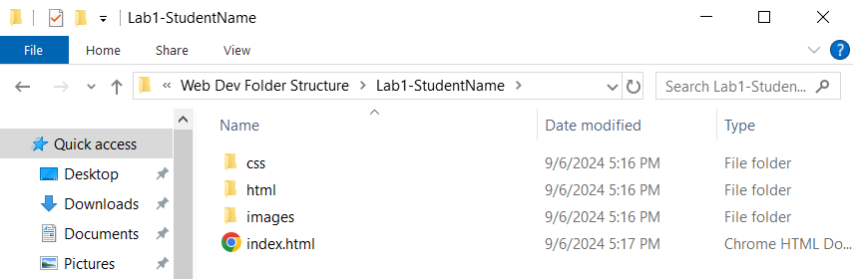

* **Create a New HTML File:**
  + Go to File > New File and save it as my_favorite_musician.html.
  + Add the basic HTML structure (<!DOCTYPE html>, <html>, <head>, <body>).

**Part 2: Adding Content (30 Minutes)**

* **Create a Heading:**
  + Add a main heading (<h1>) at the top of your <body> section with the name of your favorite musician.
* **Write a Paragraph:**
  + Add a paragraph (<p>) describing why you like this musician. Mention their music style, favorite songs, or albums.
* **Create a List:**
  + Use an unordered list (<ul>) to list 3-5 of your favorite songs or albums by this musician.
* **Insert an Image:**
  + Include an image (<img>) of the musician or an album cover. You can use a placeholder image link or an image from your computer.
* **Add a Hyperlink:**
  + Include a hyperlink (<a>) to the musician's official website or a music streaming service where others can listen to their music.

**Part 3: Final Touches (10 Minutes)**

* **Preview Your Page:**
  + Save your file and open it in a web browser to see how it looks. Make adjustments as needed.
* **Add Comments:**
  + Go through your code and add comments to explain what each section does.
* **Experiment:**
  + Try adding more elements (like another paragraph about their biography, a list of band members, or more images) to enhance your web page.

**Submission**

Show your facilitator your work and upload to Google Classroom. Don’t forget to zip your Lab folder first!